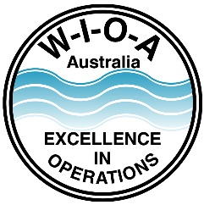
Water Industry Operators Association of Australia

P.O. Box 6012
Shepparton, Victoria 3632

Water Industry Operator Registration Scheme
RE-REGISTRATION PROFESSIONAL DEVELOPMENT
Exceptional Activities

EVIDENCE OF EXCEPTIONAL ACTIVITIES
Provide details of exceptional activities that you would like recognised as part of your ongoing professional development.

Applicants are to complete this page for each activity to be recognised.

Applications will be reviewed by WIOA on a case by case basis with a maximum of 10 points awarded for this category.

Attach additional documentation as evidence of undertaking this activity.

Activity ______________________________________________________________________
______________________________________________________________________

Description ______________________________________________________________________
______________________________________________________________________
______________________________________________________________________

Dates of Activity Start Date ______/______/______
End Date ______/______/______

Attach detailed documentation of your project.

OFFICE USE ONLY

Number of Points Allocated

Authorised by on

