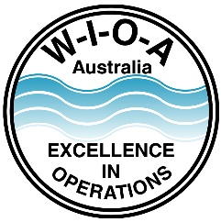
Water Industry Operators Association of Australia

P.O. Box 6012
Shepparton, Victoria 3632

Water Industry Operator Registration Scheme
RE-REGISTRATION PROFESSIONAL DEVELOPMENT
Non-Accredited Training
STATEMENTS OF ATTENDANCE
Please list all professional development activities that you would like recognised as part of your ongoing professional development.

Attach copies of the statements of attendance or a statement of competencies achieved provided by the organisation or person responsible for the delivery of the program.
PROFESSIONAL DEVELOPMENT - STATEMENTS OF ATTENDANCE

Date of Attendance | Unit Name | Delivered by | Duration | Points  Claimed  Year
Eg: 15/6/2020 | Sodium Hypochlorite Short Course | Hydramet | 8 Hours | 3

