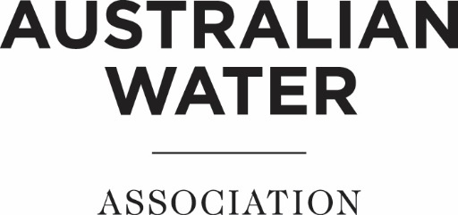
QLD Operator of the Year Award
Nomination Form

The award is presented to operators of water or wastewater treatment facilities to recognise excellent performance initiative, attitude, reliability, environmental stewardship safety awareness, and all round attention to detail.
The Award will be presented at a date to be advised as part of an event in the Queensland Water Industry.

Nominee:
Title/Profession:
Organisation:
Postal address:
Phone:
Mobile:
Email:
(If Applicable)
Nominator:
Title/Profession:
Organisation/Affiliation:

Postal address:

Phone:
Mobile:
Email:

Eligibility: Queensland Employers/Employees (Water Authorities, Councils, private water industry) are invited to nominate operators from their organisations. Nominees can be nominated from all operations staff with work duties related to the operational area of water and waste water and related areas. Previous winners are eligible to be nominated.

A panel of industry experts will select a winner based on the following:
- Overall plant management, performance and presentation
- Knowledge and input into plant process
- Understanding of, whilst showing diligence with, environmental issues
- The demonstration of initiative and innovation in process operation
- Showing due diligence and leadership in workplace health and safety
- Being an active team member and giving encouragement

Submissions should include:
- A completed nomination form
- An executive summary outlining the main reason for the nomination (maximum 500 words)
- Detailed information introducing the nominee and addressing the criteria (maximum 4 A4 pages)
- 2 or 3 High Resolution Photos (jpg format)
- Biography (minimum 180 words, maximum 300 words)
- Two letters of reference

Nominations should be submitted electronically in Word or PDF format to
Queensland Member Engagement Manager, AWA at qldbranch@awa.asn.au.
Closing Date: 5pm, Friday 23rd April 2021

