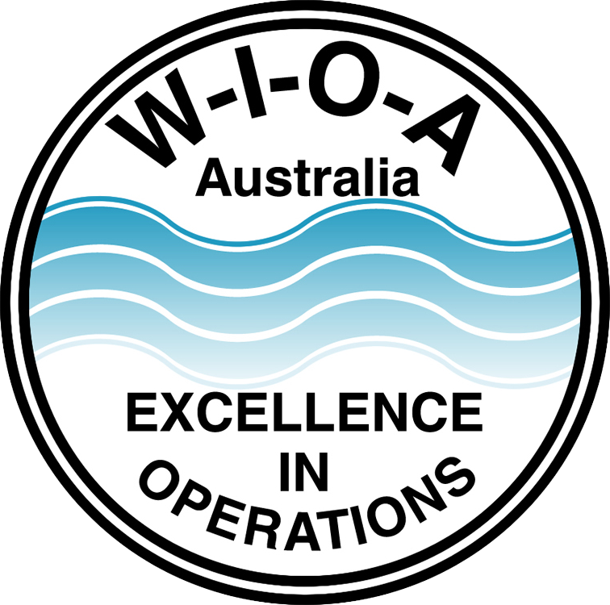
Kwatye Cultural Recognition Award – Application Form

Applications close 20th August annually.

The application must be received by the WIOA Secretary via email: info@wioa.org.au or post marked no later than 20th August.

Postal address: PO Box 6012, Shepparton, Victoria, 3632.

Applicant Information

Name ...........................................................................................................................
Position ...........................................................................................................................
Employer ...........................................................................................................................
Address ...........................................................................................................................
State ........................................................... Postcode ....................................
Telephone ........................................................... Mobile ....................................
Email ...........................................................................................................................
Project Title ...........................................................................................................................

The following items must accompany the application form:
- Outline the initiative involving cultural or diversity and inclusion-based activities within a project and/or community in which the applicant serves. (Maximum 1 page)
- Include a personal profile on the applicant. This should include skills, qualifications, work experience, interests, and hobbies. (Maximum 1 page)
- Applicants must sign the declaration at the end of the application form.

Kwatye Cultural Recognition Award – Application
THE INITIATIVE

Outline the initiative involving cultural or diversity and inclusion-based activities within a project and/or community in which the applicant serves. (Maximum 1 page)

About the initiative

Diversity and Inclusion goals

Impact

Innovation

Kwatye Cultural Recognition Award – Application
THE APPLICANT

Include a personal profile on the applicant. This should include skills, qualifications, work experience, interests and hobbies. (Maximum 1 page)

About the applicant

Skills

Qualification

Work Experience

Interests and Hobbies

Kwatye Award – Eligibility, Criteria & Conditions
Eligibility
- The award is open to individual Members of WIOA
- Applicants must be employed in an operational role in the water industry
- Applicants must not be employed by a “product supplier” (can be from a company providing operational services to the industry)
- Applicants must have employer support and their endorsement to apply

Sharing outcomes with the industry
- The Award winner will produce an article that can be reproduced in a WIOA publication on their nomination
- The Award winner will present their nominated project to an audience of WIOA members (eg: at WIOA interest day, webinar).

Criteria
The Selection Committee will assess all applications based on the following criteria:

Diversity and Inclusion goals
The extent to which the program or initiative has been designed to promote and support diversity and inclusion in the workplace or community they serve, such as access, participation and connection for co-workers, members of the community and people from disadvantaged and marginalised groups.

Impact
The extent to which the program or initiative has benefited co-workers, members of the community and people from disadvantaged and marginalised groups.

Innovation
The level of creativity, imagination, and innovation demonstrated within the program or initiative.

Conditions
- It is the responsibility of the Applicant to ensure that the appropriate permission is sought in advance of nominating for this award.
- All or parts of the application (excluding the personal profile) may be used by WIOA to publicise the Award.
- If required short-listed Applicants must attend an interview with the judging panel at a mutually agreed time and place.
- The judging panel reserves the right not to award the Award in any given year if, in their opinion, the applications do meet an acceptable standard.
- The decision of the judging panel is final and cannot be contested.
- The Award winner will be required to present one written report and one oral presentation at a WIOA event within the following year.

Declaration; I have read and understood the conditions for entering the Kwatye Cultural Recognition Award.

Signature of Applicant: ...................................................................................................................
Print Name: .......................................................................... Date: ........./.........../................

